Additional file

Collaborative subcellular compartmentalization to improve GPP utilization and boost sabinene accumulation in Saccharomyces cerevisiae

Hong-Jie Jia^{1, 2#}, Tian-Hua Chen^{1, 2#}, Jun-Ze Qu^{1, 2}, Ming-Dong Yao^{1, 2}, Wen-Hai Xiao^{1, 2}, Ying Wang^{1, 2*}, Chun Li^{1, 3}, Ying-Jin Yuan^{1, 2}

¹ Frontier Science Center for Synthetic Biology and Key Laboratory of Systems Bioengineering (Ministry of Education), School of Chemical Engineering and Technology, Tianjin University, Tianjin 300072, China
² Collaborative Innovation Center of Chemical Science and Engineering (Tianjin), Tianjin University, Tianjin 300072, China
³ Institute for Biotransformation and Synthetic Biosystem/Department of Biological Engineering, School of Life Science, Beijing Institute of Technology, Beijing 100081, China

# These authors contributed equally to this work.

*Corresponding author:
Ying Wang (E-mail: ying.wang@tju.edu.cn, Tel: 86-22-60973987, Postal address: No. 92, Weijin Road, Nankai District, Tianjin, 300072, PR China)
Co-authors:
Hong-Jie Jia (E-mail: jhj18526440154@163.com)
Tian-Hua Chen (Email: 13102217875@163.com )
Jun-ze Qu (Email: 18222962721@163.com)
Ming-Dong Yao (Email: mingdong.yao@tju.edu.cn)
Wen-hai Xiao (Email: wenhai.xiao@tju.edu.cn)
Chun Li (Email: lichun@bit.edu.cn)
Ying-Jin Yuan (Email: yjyuan@tju.edu.cn)

Fig. S1 Schematic diagram of plasmids construction and DNA manipulation in this study. a Expression of truncated sabinene synthase (t34SabS1) along with ERG20^{ww} by centromeric plasmid. b Downregulation of the wild type ERG20. c Targeting t34SabS1 into peroxisomes (fused with SKL) and mitochondria (fused with MLS). d Expression of RFP fused t34SabS1 that targeting into peroxisomes or mitochondria.

Fig. S2 The GC-TOF-MS profile of sabinene standard, the control strain and sabinene producing strain.

Fig. S3 Predicted disorder structure of sabinene synthase. Arrows indicate truncated positions within the N-terminus of sabinene synthase, and the box corresponds to the RRX (8) W sequence.

Fig. S4 Sabinene output for sabinene synthase combined targeting to different location combination.

Fig. S5 Effects of overexpression of ten proteins associated with mitochondrial dynamics on sabinene production. * means p <0.05, ** means p <0.01.

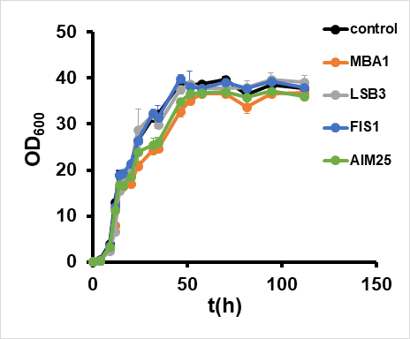
Fig. S6 Cell growth of strains with overexpression of FIS1, LSB3, MBA1 and AIM25.

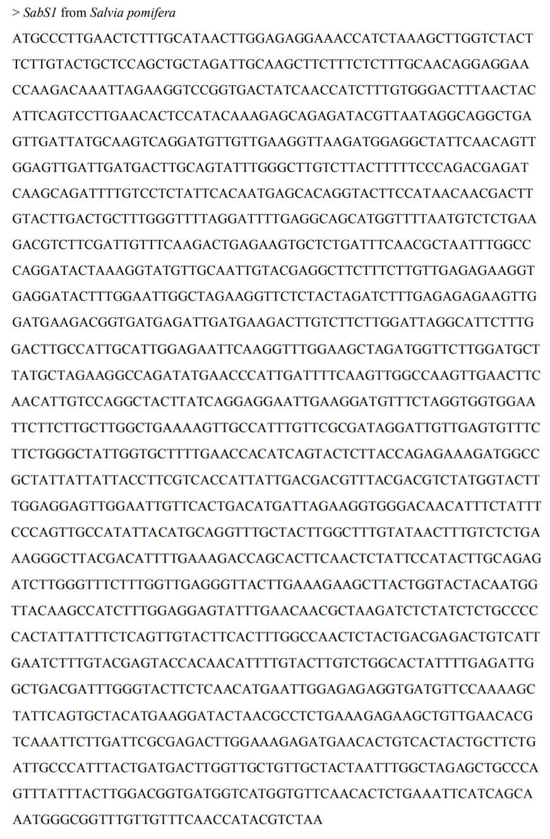
Fig. S7 Codon-optimized Salvia pomifera sabinene synthase involved in this study.
Table S1. Plasmids used in this study
plasmid | Description | Source
pRS415 | single-copy plasmid with the ampicillin resistance marker | Addgene
pRS416 | single-copy plasmid with the ampicillin resistance marker | Addgene
pYGG415 | Introducing synonymous mutations at the BsaI site within the ampicillin resistance marker based on pRS415 | Our laboratory
pYGG416 | Introducing synonymous mutations at the BsaI site within the ampicillin resistance marker based on pRS416 | Our laboratory
pJGZ3 | pRS415K-GAL80up-T_{ADH1}-P_{GAL1,10}-T_{TDH2}-His-GAL80down | [1]
peasy-loxp | pEASY- loxP-URA3-loxP | Our laboratory
pRS417-Cre | pRS417-P_{GAL1}-Cre-EBD-T₉₇-KanMX | Our laboratory
pYGG415D | pYGG415-T_{ADH1}-P_{GAL1,10}-T_{TDH2} | This study
pYGG415E | pYGG415-T_{ADH1}-ERG20^{WW}-P_{GAL1,10}-T_{TDH2} | This study
pYGG415E1 | pYGG415-T_{ADH1}-ERG20^{WW}-P_{GAL1,10}- SabS1  -T_{TDH2} | This study
pYGG415Et43 | pYGG415-T_{ADH1}-ERG20^{WW}-P_{GAL1,10}- t43SabS1  -T_{TDH2} | This study
pYGG415Et34 | pYGG415-T_{ADH1}-ERG20^{WW}-P_{GAL1,10}- t34SabS1  -T_{TDH2} | This study
pYGG415Et52 | pYGG415-T_{ADH1}-ERG20^{WW}-P_{GAL1,10}- t52SabS1  -T_{TDH2} | This study
pCTH01 | pYGG415-T_{ADH1}-ERG20^{WW}-P_{GAL1,10}- SabS1--RFP-T_{TDH2} | This study
pCTH02 | pYGG415-T_{ADH1}-ERG20^{WW}-P_{GAL1,10}- t43SabS1  --RFP-T_{TDH2} | This study
pCTH03 | pYGG415-T_{ADH1}-ERG20^{WW}-P_{GAL1,10}- t34SabS1  --RFP-T_{TDH2} | This study
pCTH04 | pYGG415-T_{ADH1}-ERG20^{WW}-P_{GAL1,10}- t52SabS1  --RFP-T_{TDH2} | This study
pCTH05 | pYGG415-P_{PEX3}-PEX3--GFP-T_{CYC1} | This study
pCTH06 | pYGG415-P_{COX4}-COX4--GFP-T_{CYC1} | This study
pJHJ01 | pYGG416-T_{CYC1}-P_{TDH3}-RFP-T_{TEF1} | This study
pJHJ02 | pYGG416-T_{CYC1}-P_{TDH3}-FIS1-T_{TEF1} | This study
pJHJ03 | pYGG416-T_{CYC1}-P_{TDH3}-MGM1-T_{TEF1} | This study
pJHJ04 | pYGG416-T_{CYC1}-P_{TDH3}-GEM1-T_{TEF1} | This study
pJHJ05 | pYGG416-T_{CYC1}-P_{TDH3}-MMM1-T_{TEF1} | This study
pJHJ06 | pYGG416-T_{CYC1}-P_{TDH3}-SNF1-T_{TEF1} | This study
pJHJ07 | pYGG416-T_{CYC1}-P_{TDH3}-ARC18-T_{TEF1} | This study
pJHJ08 | pYGG416-T_{CYC1}-P_{TDH3}-LSB3-T_{TEF1} | This study
pJHJ09 | pYGG416-T_{CYC1}-P_{TDH3}-JSN1-T_{TEF1} | This study
pjhj10 | pYGG416-T_{CYC1}-P_{TDH3}-MBA1-T_{TEF1} | This study
pjhj11 | pYGG416-T_{CYC1}-P_{TDH3}-AIM25-T_{TEF1} | This study
‘--' refers to the fusion of the proteins before and after this symbol. And ‘t34SabS1’refers to the sabinene synthase derived from Salvia pomifera.
Reference
1. Jiang G, Yao M, Wang Y, Zhou L, Song T, Liu H, et al. Manipulation of GES and ERG20 for geraniol overproduction in Saccharomyces cerevisiae. Metab Eng. 2017; 41:57-66.

Table S2. Primer used in this study
Primer | Sequence (5’- 3’)
GAL1-seq-F | GGTAATTAATCAGCGAAGCGATGA
TDH2t-seq-R | CGTGTATATGAGATGTCATGAGCATG
Trp1-L-F | GGAAGAGGAGTAGGGAATATTACTGGC
GAL1-SPsabS1-F | CGTCAAGGAGAAAAAACTATAATGCCCTTGAACTCTTTGCATAACTTGG
Gal1-t34SpSabS1-F | CGTCAAGGAGAAAAAACTATAATGCAACAGGAGGAACCAAGACAAATTAGAAGGTC
Gal1-t43SpSabS1-F | CGTCAAGGAGAAAAAACTATAATGTGGGACTTTAACTACATTCAGTCCTTGAACACTC
t4SpSabS1-part43- R | AGATTCAATGACAGTCTCGTCAGTAGAGTTAGCGTTGTTCAAATACTCCTCCAAAGATG
t4SpSabS1-part2-F | ATCTTTGGAGGAGTATTTGAACAACGCTAACTCTACTGACGAGACTGTCATTGAATC
TDH2t-SpsabS1-R | AGTAACTTAAGGAGTTAAATTTTAGACGTATGGTTGAAACAACAAACCGC
SP-GS-RFP-F | TGTTTCAACCATACGTCGGTAGCATGGTTTCAAAAGGTGAAGAAGATAATATG
RFP-GS-SP-R | TCTTCACCTTTTGAAACCATGCTACCGACGTATGGTTGAAACAACAAACCGCCCATTTG
TDH2t-RFP-R | TAAAGTAACTTAAGGAGTTAAATTTTATTTATATAATTCATCCATACCACCAGTTGAATG
F-GAL10-ERG20^{WW}-F | ACTTTAACGTCAAGGAGAAAAAACTATAATGGCTTCAGAAAAAGAAATTAGGAG
ERG20p-F | CAATGCTTCCTCTGTGAGATCAGGC
ERG20p-R | GTAGATAGCAGCCTCTAACATGAATGCG
Ura-R | GCATAGGCCACTAGTGGATC
Gib-Hxt1-F | GTGATATCAGATCCACTAGTGGCCTATGCGTGCAGGTCTCATCTGGAATATAATTCC
Gib-Hxt1-R | CTCTCTCCTAATTTCTTTTTCTGAAGCCATGATTTTACGTATATCAACTAGTTGAC
ERG20-F | ATGGCTTCAGAAAAAGAAATTAGGAGAG
HO-seq-F | ATGCTTTCTGAAAACACGACTATTCTGATGGCTAACGG
GAL1-HOUP500- R | AGTAAGAATTTTTGAAAATTCAATATACTAACTTCAATGTCAAAGTTGAAATATTCTCCTTTAGAGCGCTC
HOUP500-GAL10-F | ACTTTGACATTGAAGTTAGTATATTGAATTTTCAAAAATTCTTACTTTTTTTTTGGATG
HODOWN500-TEFt-R | ACGGGTTCCCTTTTTATAATTGGCGGAACCAGTATAGCGACCAGCATTCACATAC
TEFt-HODOWN500-F | GTATGTGAATGCTGGTCGCTATACTGGTTCCGCCAATTATAAAAAGGGAACCCGTATATTTCAGCTTC
HODOWN500-R | TAGCAGATGCGCGCACCTGCG
HO UP500taq-F | AGAAGCTTGTTGAAGCATGATGAAGC
SPJIE2-taq-R | ACCTTCTAGCCAATTCCAAAGTATCCTC
GAL1-TRPLHA-R | AGTAAGAATTTTTGAAAATTCAATATATACGATGCTGTTCTATTAAATGCTTCC
TRPLHA-GAL1-F | AGCATTTAATAGAACAGCATCGTATATATTGAATTTTCAAAAATTCTTACTTTTTTTTTGGATGGAC
TRPRHA-TDH2t- R | CGTCATAACTGCAAAGTACACATATATGCGAAAAGCCAATTAGTGTGATACTAAG
TRP1-R-F | ATATATGTGTACTTTGCAGTTATGACG
TRP1-R | CTATTTCTTAGCATTTTTGACGAAATTTGC
TRPLHA taq-F | ACTGACGAAGGTTTGGACAGTGAC
yeGFP-F | ATTTACCGTAAGTAGCATCAC
TEF1T-R | tgacaaaatgcttcacaaccctg
FIS1-F | ATAAACACACATAAACAAACAAAatgaccaaagtagatttttggcc
FIS1-R | gtcttatcaatctccttatttTttaccttctcttgtttcttaagaag
MGM1-F | ATAAACACACATAAACAAACAAAatgaatgcgagcccagtacgg
MGM1-R | gtcttatcaatctccttatttTtTataaatttttggagacgcccttg
GEM1-F | ATAAACACACATAAACAAACAAAatgactaaagaaacgattcgggtag
GEM1-R | gtcttatcaatctccttatttTttattttgagaattttgatgatttgaataatttc
MMM1-F | ATAAACACACATAAACAAACAAAatgactgatagtgagaatgaatccacc
MMM1-R | gtcttatcaatctccttatttTttataactctgtaggcttttcttctc
SNF1-F | ATAAACACACATAAACAAACAAAatgagcagtaacaacaacacaaac
SNF1-R | gtcttatcaatctccttatttTtTaattgctttgactgttaacggc
ARC18-F | ATAAACACACATAAACAAACAAAatgcctgcgtatcactcgactttc
ARC18-R | gtcttatcaatctccttatttTttatagagatttgttcatgaatcttcttcttgtg
LSB3-F | ATAAACACACATAAACAAACAAAatgggtattaacaatcctattccaagg
LSB3-R | gtcttatcaatctccttatttTttaaactagttcaacgtaatttgctgg
JSN1-F | ATAAACACACATAAACAAACAAAatggataaaagtaagcagatgaacatc
JSN1-R | gtcttatcaatctccttatttTtTagtttgcagagtgtaaagtcagag
MBA1-F | ATAAACACACATAAACAAACAAAatgagtgtattaagatctacatgcc
MBA1-R | gtcttatcaatctccttatttTttagcttggaggtaaacgatatatatcacc
AIM25-F | ATAAACACACATAAACAAACAAAatgcatagaacggcaatatttctaac
AIM25-R | gtcttatcaatctccttatttTTtactcatcatagccaccgccaaaag
TDH3P-YZ-F | TGATGACACAAGGCAATTGACCCAC
FIS1-YZ-R | tcaccgagtttgtagcaacctatg
MGM1-YZ-R | tcatcctcgtcatcatcatcttcg
GEM1-YZ-R | atgacagccaatggctttagttc
MMM1-YZ-R | tctgcctcttcattgagctcgtag
SNF1-YZ-R | tgtgcctatggcagtactcgac
LSB3-YZ-R | tcgacaagtcatcgacttcacgg
SN1- YZ-R | tgttgcaaaaggtgctgttgcatg
HOL-F | TCCTACCATCAAGCGTCTGACATTG
HOL-R | agcgtgacataactaattacatgATGCTTTCTGAAAACACGACTATTCTG
CYC1t-F | AGTCGTGTTTTCAGAAAGCATcatgtaattagttatgtcacgcttacattcac
TEF1t-R | tcaaaaaaaagaataaaaaaaaaatgatgaattgaagatagcgccgatcaaagtatttg
URA-F | ctttgatcggcgctatcttcaattcatcattttttttttattcttttttttgatttcgg
URA-R | cctgatgcggtattttctccttacg
HOR-F | agaaaataccgcatcaggTCTGCAAACCTCATTTGAGTAGCAATAGC
HOR-R | CGCAAGTCCTGTTTCTATGCCTTTC
HO-YZ-F | agagcgctccatttcttctatgaag
TEF1t-YZ-F | tcatcagggttgtgaagcattttgtc
HOR-YZ-R | agggcaaatgtattcatgtgtgtc
URA-L-F | TTCATCATCTCATGGATCTGCACATG
URA-L-R | accggcatgAAGCTTTATGGACCCTGAAACCAC
ADH1t-F | TTTCAGGGTCCATAAAGCTTcatgccggtagaggtgtggtc
TDH2t-R | tgagtattcccacagttgcgaaaagccaattagtgtgatac
LEU-F | tggcttttcgcaactgtgggaatactcaggtatcg
TDH2t-F | tcatgctcatgacatctcatatacacg
LEU-R | AGATTCCCGGGTAATAACTGagaaggtattgacttaaactccatcaaatgg
URA-R-F | CAGTTATTACCCGGGAATCTCGGTC
URA-R-R | CGGCCCAAGCCTTGTCCCAAG
URA-YZ-F | actagggaagacaagcaacgaaac
LEU-YZ-R | agcgatagtaactattgaattttgtttgg
URA-YZ-R | tgttgcaggcttacTGGttggtc
SAB-YZ-F | ACTTGGACGGTGATGGTCATGG
SAB-YZ-R | taggcaatggtggctcatgttg
LEU-YZ-F | agtgaacaatacaccgttccagaag

